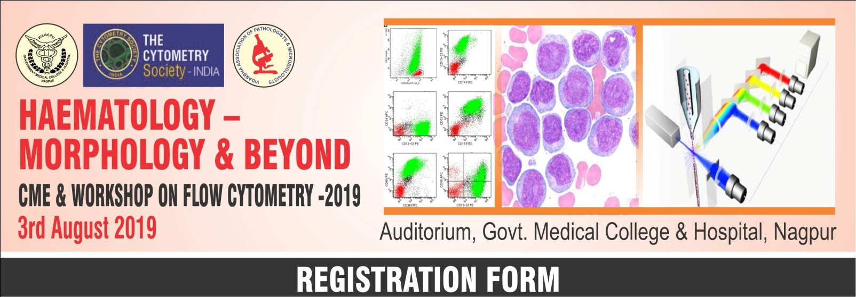
(Please fill in the registration form and send as email or hard copy to the Workshop Coordinator)
Date : | 3rd February, 2019
Venue : | : Auditorium, Govt. Medical College, Nagpur
Name :
Age : |  | Gender:
Specialty :
Current Position :
Organization / Institute :
Contact No. |  | Email l D :
Address for Correspondence :
Are you TCS Member ? Yes/No
If Yes, mention the Membership No. :
Are you a student : Yes/No :
(Please enclose a signed letter from the Head of Department of your Institute)
Payment details:
Payment Mode : DD/Cheque/Cash/NEFT :
Amount :
Amount (in words) :
DD/ Cheque /Transaction ID No.:
Dated :
Bank Branch :
Signature : Date :
Department of Pathology, Heamatology Section, Government Medical College & Hospital, Nagpur
Note : Please fill in the registration form and send as email or hard copy to the Workshop Coordinator

